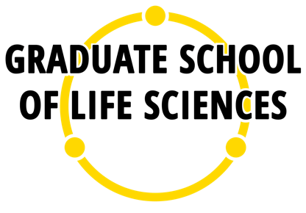

Training & Supervision Agreement
(TSA)

for PhD candidates of the
Utrecht University Graduate School of Life Sciences

Introduction

Dear PhD candidate,

Welcome to the Utrecht University Graduate School of Life Sciences (GSLS), a collaboration between the Faculties of Veterinary Medicine, Science and Medicine (UMCU). The mission of the GSLS is to improve life by providing an inspiring and innovative academic environment that enables our graduates to thrive in the dynamics of life sciences and society. The GSLS is a large, multidisciplinary organisation with currently over 1,500 Master students and approximately 1,800 PhD candidates. The GSLS covers the Master's degree courses Biomedical Sciences, Neuroscience & Cognition, Health Sciences, Biosciences, and Science & Business. The doctoral education of GSLS is organised in currently 15 programmes, most of which are connected to corresponding Master’s programmes and are embedded in the strategic research theme Life Sciences of Utrecht University and the thematic research programme of UMC Utrecht.

According to the EU Bologna process, doctoral education has been defined as the third cycle in higher education, i.e. the cycle following the Bachelor and Master phases. The main goal of doctoral education is to facilitate the development of the PhD candidate into an independent scientist by training and coaching as well as by providing the desired environment and structure. Future scientists in the Life Sciences require knowledge and expertise in a specific field of science as well as a critical academic attitude. At the same time, insight and experience in other disciplines are required to be able to work in an interdisciplinary setting. This implies that at the end of the doctoral education at the GSLS you graduate as a person with specific academic skills and competences rather than merely delivering a doctoral thesis. You will not only grow during your doctoral education in terms of research skills and knowledge, but you will also develop other relevant personal and professional competences (see www.phdcompetencemodel.nl and our website). Science is teamwork and you are part of a research team and also an active member of a broader community of researchers in a certain thematic area.

Training and Supervision Agreement (TSA)
The Training and Supervision Agreement (TSA) is a standard agreement between you as PhD candidate and the supervisory team to ensure proper training and supervision of you during the PhD track. The TSA contains the name of the PhD programme to which you have been admitted (if applicable) and the names of your supervisory team. This data has to be electronically documented in the Utrecht University wide PhD tracking system MyPhD. In addition, the TSA contains the Individual Training Plan listing your intended training activities including thematic and general training and research related meetings. The Individual Training Plan includes the compulsory courses Responsible Conduct of Research and relevant teaching training (if you are involved in specific teaching activities; more information at our website). The TSA has to be submitted within three months after the start of your PhD track. This is done by uploading this form with the required information in MyPhD. Your supervisors and PhD programme coordinator have to approve your TSA in MyPhD. Fill in this document in consultation with your supervisors and your PhD programme coordinator.

Your TSA is a living document. As your PhD progresses it is common that the initial Individual Training Plan is adjusted, for example in relation to the yearly progress meetings. In that case you can adjust the TSA and resubmit it to MyPhD.

Each version of the TSA that you upload in MyPhD will automatically – via MyPhD – be sent to your supervisors, the PhD programme coordinator and to the manager responsible for research in your division (Faculty of Medicine), head of department (Faculty of Science) or vice dean of research (Faculty of Veterinary Medicine) for approval.

Supervision
During your PhD track, you will be supervised by one or more supervisors (promotores: full professors, or associate professors endowed with ius promovendi; the primary supervisor being affiliated with Utrecht University or UMC Utrecht) and one or more daily supervisors (copromotores: associate or assistant professors of Utrecht University, UMC Utrecht or other knowledge institutions). In addition, 1 or 2 independent advisors must be appointed, who are not involved in your project. All these elements of your supervision are registered in the registration form of MyPhD as well.

The Individual Training Plan
Your Individual Training Plan refers to the collection of training activities to which you as a PhD candidate of the GSLS have access. On average the GSLS faculties and associated institutions allocate a budget of € 1,000 per PhD candidate per year. This is not a personal budget but used by the PhD programmes to maintain an active and inspirational PhD community and to organize trainings and events, as well as by the PhD Course Centre to offer trainings in general skills and competencies and to organize events for the entire GSLS PhD community.

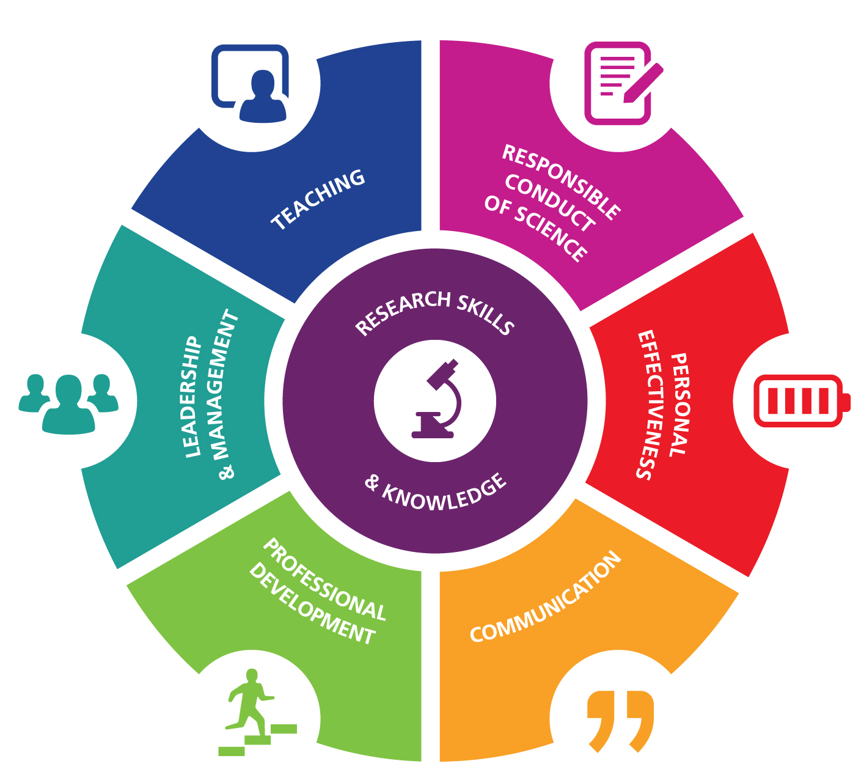

It is important to develop your competencies as a researcher and as an individual (see www.phdcompetencemodel.nl). Meaningful competencies to develop are: Research Skills & Knowledge, Responsible Conduct of Science, Personal Effectiveness, Professional Development, Leadership & Management, Communication and Teaching. These competencies lead to further development to prepare you for an academic future as well as for a future outside academia.

General training in professional competencies and skills are available via the PhD Course Centre of the GSLS (see bit.ly/PhDCourseCentre) or Utrecht University (e.g. Development Guide including Career Services). Thematic training is provided by each of the PhD programmes of the GSLS. PhD candidates are offered the opportunity to attend meetings (such as courses, seminars, master classes, journal clubs, PhD retreats) organised by the PhD programmes and/or research institutes or the national and/or international research networks/schools. PhD candidates are encouraged to attend guest lectures and to participate in (international) symposia and conferences. It is the responsibility of the PhD programmes to organise these meetings and to maintain an active and inspirational community of PhD candidates.

Your PhD Training Portfolio
During your PhD track you will collect evidence (certificates of attendance) of the training activities you have followed; together constituting the PhD Training Portfolio. You will use your portfolio during the annual PhD progress meetings. Based on the contents of this PhD Training Portfolio the PhD programme management, on behalf of the Board of Studies (BoS), will decide whether at the end of the PhD track you qualify for the Training Certificate of the GSLS. The Training Certificate is usually handed over at the end of the PhD defence ceremony.

The requirements to receive the Training Certificate are the following:
- Training should comprise a minimum of 5 credits for each fulltime equivalent year of research appointment, which will be at least 3 years (at least 15-20 ECs in total).
- A minimum of 40% of the total credits should be spent on discipline-specific educational activities (e.g. courses/training/events) of the PhD programme to which the PhD candidate has been admitted or other PhD programme or institute.
- A minimum of 20% of the total credits should be spent on general educational activities (e.g. courses/training/events).
- A maximum of 20% of the total credits may be spent on symposia/conferences where you are a presenter.

According to the European Credit Transfer System (ECTS) 1 credit = 28 hrs and 1.5 credit = 1 week.

The procedure for application of the Training Certificate and the application form can be found on the website of the GSLS. Please request your Training Certificate at least 2 months before your defence.

1. Personal Information

Name PhD candidate
Graduate School | Graduate School of Life Sciences

PhD programme
Faculty * | Science / Veterinary Medicine / Medicine

Teaching Tasks (in FTE or %)

Clinical Tasks (in FTE or %)

*Faculty: fill in the faculty where you will defend your thesis. This is the faculty your first promotor is affiliated with.

2. Supervision

Name(s) supervisor(s)

[promotor(s)]

Name(s) co-supervisor(s)

[co-promotor(s)]

Name(s) independent advisor(s)

3. Individual Training Plan

Rows may be added if necessary
Discipline-specific educational activities (e.g. courses/training/events) offered by the PhD programme or other programme or institute  min. 40% of total | Organising Institute | European Credits
General educational activities (e.g. courses/training/events) (e.g. from the PhD Course Centre)  min. 20% of total | Organising Institute | European Credits
Responsible Conduct of Research (compulsory) | Utrecht University
Training in teaching (compulsory for PhD candidates with teaching tasks), e.g. Supervising MSc students: Starter Kit; Supervising Research of MSc students; Start to Teach. | Utrecht University
Symposia/conferences (oral or poster presentation) or other relevant activities  max. 20% of total | Organising Institute | European Credits
TOTAL

PhD programmes of the Graduate School of Life Sciences can be found at https://www.uu.nl/en/lifesciences/phd-programmes. In case the PhD candidate is not part of one of these PhD programmes, the managing director of doctoral education of the GSLS will act as ‘programme coordinator’.

